Protocols Learnings in detail using Wireshark filter and flow Graph

AIM:
To study and analyze five important network protocols—TCP, UDP, ARP, ICMP, and HTTP—using Wireshark, and understand how they work in real network communication.
Five Protocols:

TCP (Transmission Control Protocol)
TCP is a reliable, connection-oriented protocol. It establishes a connection using a three-way handshake (SYN, SYN-ACK, ACK) and ensures safe and ordered data delivery.

2. UDP (User Datagram Protocol)
UDP is a fast, connectionless protocol. It sends data without establishing a connection or waiting for acknowledgment.

3. ARP (Address Resolution Protocol)
ARP is used to find the MAC address of a device when its IP address is known. It sends a broadcast request and receives a reply.

4. ICMP (Internet Control Message Protocol)
ICMP is used for network testing and error messages. The ping command uses ICMP Echo Request and Echo Reply.

5. HTTP (Hypertext Transfer Protocol)
HTTP is an application layer protocol used to load websites. It works on a request–response model over TCP.

DIAGRAM:
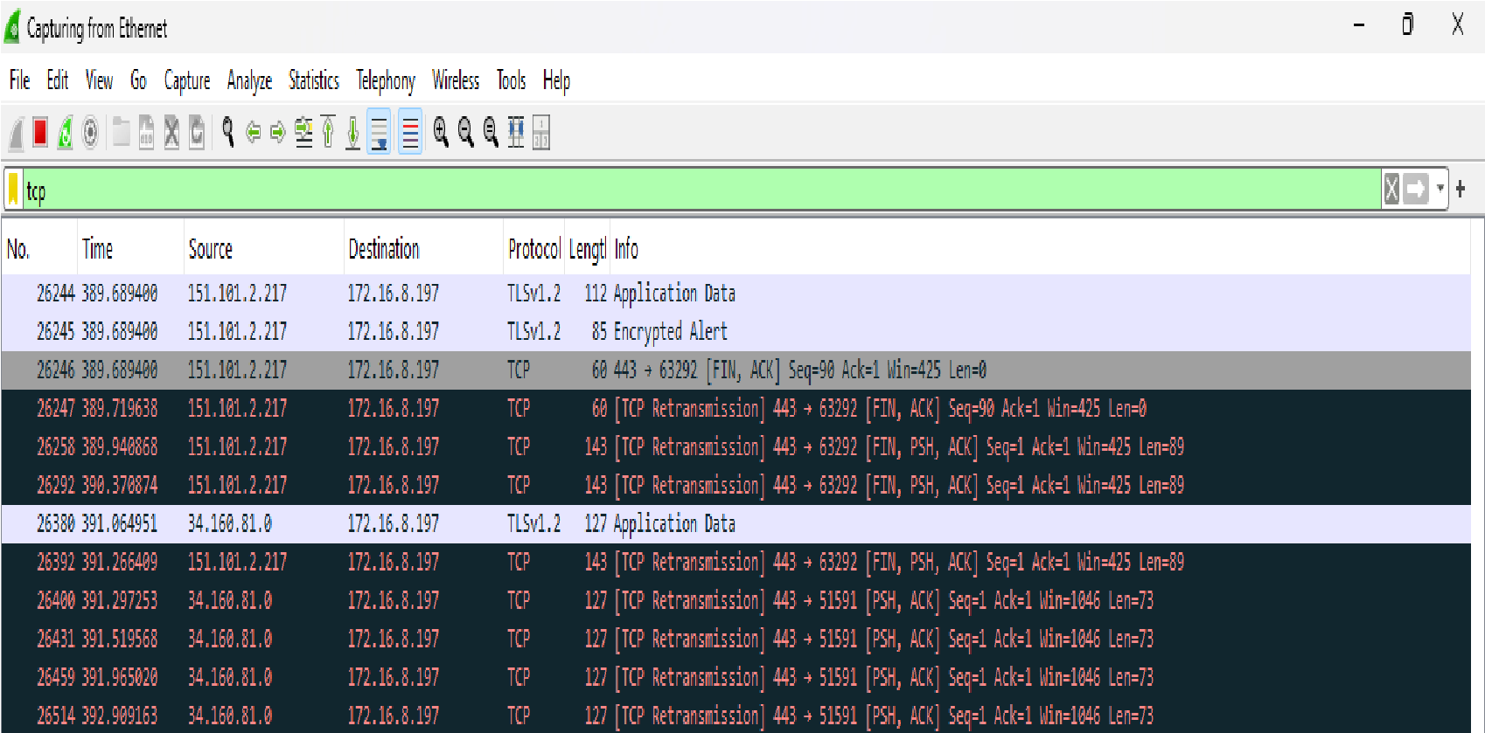

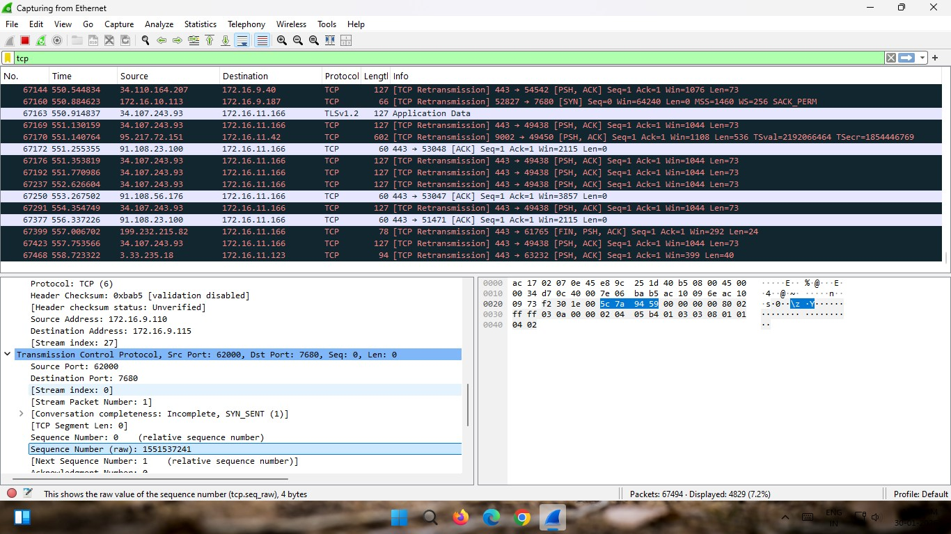

Procedure:
- Open Wireshark and select the active network interface.
- Start packet capture.
- Generate traffic by browsing websites or using commands like ping and nslookup.
- Stop capture after collecting enough packets.
- Apply filters like tcp, udp, arp, icmp, and http.
- Observe packet details and use Flow Graph to see communication flow.

Observations:
- TCP showed a three-way handshake before sending data.
- UDP sent packets without connection setup.
- ARP showed broadcast request and reply for MAC address.
- ICMP displayed Echo Request and Echo Reply.
- HTTP showed GET request and 200 OK response.

Result:
The experiment was completed successfully. The working of TCP, UDP, ARP, ICMP, and HTTP was clearly understood using Wireshark packet capture and flow analysis.

